Please print this document and bring it with you on the day, as hard copies will not be issued.

Coxswain & Crew Notes

The club will be open for registration from 8:30 onwards, the galley will serve breakfast and refreshments from 9:00.
We advise all crews to arrive early and be prepared to launch larger boats well before the cox briefing.
- Safety Boat briefing: - 10:00
- Cox and Crew briefing: - 10:30

Race Start times

Bursledon Gigs: 12:00
Felixstowe Clayton Skiff: 12:05
Celtic Longboats: 12:10
Solent Galley/Pilot Gigs: 12:15

Weather and Tide

Tide:

HIGH LOW
12:39 17:45
4.79 m 1.19m

Weather forecast :

To be advised at the briefing on race day.

Handicap system to be applied

In line with other clubs in the 3 Harbours Rowing Group, it has been agreed that the Ouse Yardstick coefficients 2025 will be used to calculate handicap results for the Tudor Challenge. Further information on the Ouse Yardstick and how it will be applied to the race results can be found here: Ouse Yardstick

Ouse Yardstick Numbers for 2025

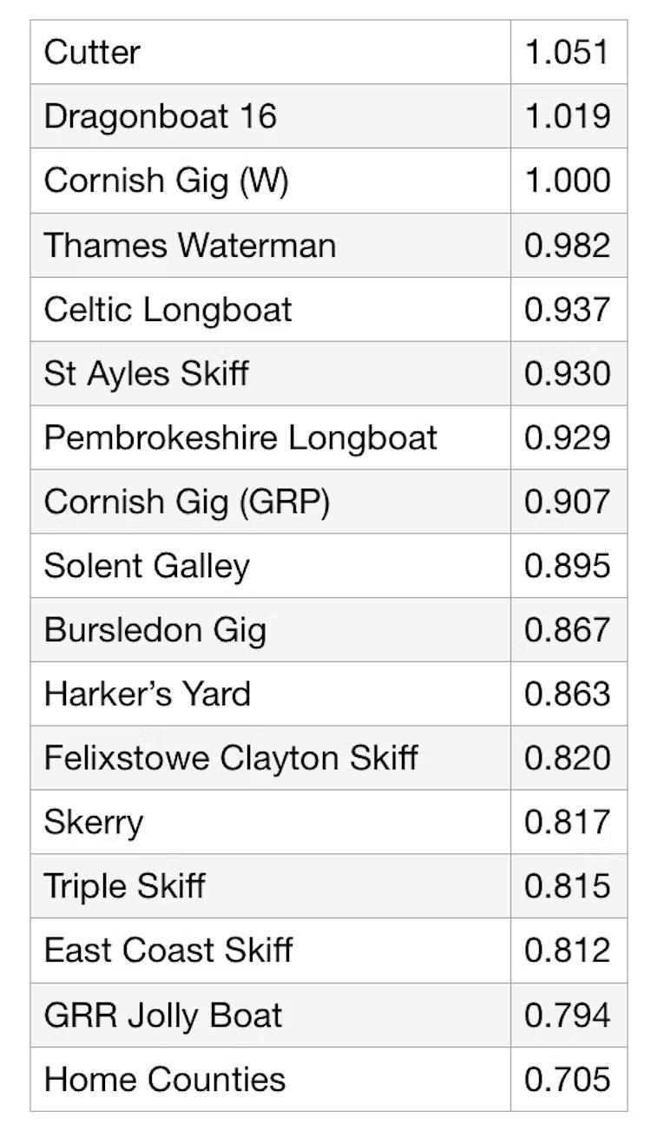
The Course

A map of the planned course is attached to these notes.

In the event of adverse weather, a shorter course will be selected, details of which will be announced on race day.

Starting Procedure

- Competing boats must be on the water in good time to meet their designated start times.
- Boats will be called forward to the start line by boat type.
- Two minutes before the start a VHF warning will be given.
- Two blasts on the air horn will be sounded one minute before the start, and a VHF warning will be given.
- At 30 seconds before the start a VHF warning will be given.
- A VHF countdown will commence 10 seconds before the start.
- The start will be signalled with one long blast on the air horn.

VHF warnings will be given on channel 37A

Course Hazards

- The race will take place on a spring tide. The tidal streams in the Harbour Entrance will be extremely strong either side of HW with possible submerging of mooring and navigational buoys.
- Dredger movements - from Kendals Wharf through Broom Channel to harbour entrance and harbour entrance through Broom Channel to Kendals Wharf. All boats are advised that the racing line must be sacrificed in favour of safety.
- Navigation marker buoys.
- Mooring buoys.
- Wreckage/ Danger marker buoys /posts.
- Moored vessels.
- Other leisure craft. Coxwains must give way to all sailing vessels.
- An unmarked sand bank located to the NE of the wrecked Mulberry.

Course participants

- Please ensure that each crew member is signed in on race day.
- Every boat must be covered by public liability insurance up to £2 million for any one claim and for any loss, injury or damage to property or persons, including all persons aboard the craft.
- Sufficient buoyancy aids must be carried for all persons aboard. Coxswains and anyone not rowing must wear buoyancy aids / lifejackets at all times in the boat.
- All rowers must be aged over 18.
- Any coxes who are under the age of 18 must be under the supervision of a parent/ guardian or crew member who has been DBS checked.
- There is no restriction on the combination of oars that can be used to row a boat. For example, all rowers will be permitted to use a pair of sculls if they wish.
- Slower boats - If a slower boat falls behind the main fleet, to ensure that the safety boats can provide effective cover, then the slower boat may be instructed to take a shortened course. Failure to comply with the instruction may result in disqualification.
Safety

- All coxes must have read and made themselves aware of the contents of the Tudor Challenge Risk Assessment, and the course details document which includes a map and photos of the buoy markers.
- All boats must carry a VHF radio, fully charged & working and capable of transmitting and receiving on channel 37A/M1.
- Clubs must be satisfied that their coxswains are competent off-shore and capable of handling the crew and boat in the rough waters that can be experienced in Langstone Harbour.
- All boats must carry a method of bailing water.
- All boats must be fitted with a bow and stern tow line.
- All Coxswains must wear a buoyancy aid/ lifejacket.
- Subject to the weather forecast the Race Officer may amend the rules to require all crew members to wear a buoyancy aid/ lifejacket if it is deemed appropriate.
- All boats must carry enough buoyancy aids/ lifejackets for all crew members.
- All boats will be checked to ensure they comply with the above requirements.
- Boats not meeting the above requirements will not be permitted to race.
- Safety boats will be available for the duration of the race.
- Please respect the safety boat crews and race officials and comply with any advice they provide. Remember, they are all volunteers.
- All boats must carry sufficient drinking water for the crew.
- Competitors are advised to wear sunscreen and hats to protect themselves from the effects of the sun.

On the Water

- A waterside manager will be allocated to coordinate the launching and mooring of boats. Please comply with any instructions issued by the waterside manager.
- All boats must display a flag of at least 3’ x 2’ when racing.
- The Start and Finish for the race will be the Tudor Sailing club start line.
- Life360 app - This year, we will be trialling the Life360 app to track boats during the race. Therefore, before race day, each crew is requested to download the app onto one crew member's mobile phone. The app which is free can be downloaded from Google Play or the App Store. Instructions will be provided on race day to allow each crew to share their location with the race organisers.

On the Shore

- Venue: Tudor Sailing Club, Eastern Road PO3 5LY. map
- Parking: Free parking is available at the club (see parking location plan), although this is limited, so please car share where possible.
- Disabled Parking: parking spaces close to the club will be made available for people with restricted mobility, but these must be reserved in advance. Please email rowing@tudorsailing.org.uk if you wish to reserve a space.
- Showers and toilets: Shower and toilet facilities are available within the clubhouse.
- Galley: Food will be available from the galley during the day, with a BBQ after the race. Drinking Water is available from the taps in the toilets.
- Bar: The bar in the clubhouse will be open most of the day.
- Trophy presentation: The Trophy presentation will be carried out after the results have been finalised. The presentation will not be delayed to allow slower boats to finish.

Proposed timings for the day are provided below:

Time | Item
8:30 | Club open for Registration and Breakfasts
10:30 | Cox briefing
12:00 - 12:15 | Staggered start.
13:45 | BBQ opens
14:00 | Fastest boats finishing
14:00 onwards | After Race Celebrations.  The bar will be open until late with entertainment.
15:30 | The majority of the boats are expected to have finished by now.
15:45 | Trophy Presentation (will be brought forward if slow boats finish early)
16:15 | Raffle to be drawn (will be brought forward if slow boats finish early)

We hope you have a wonderful day!

