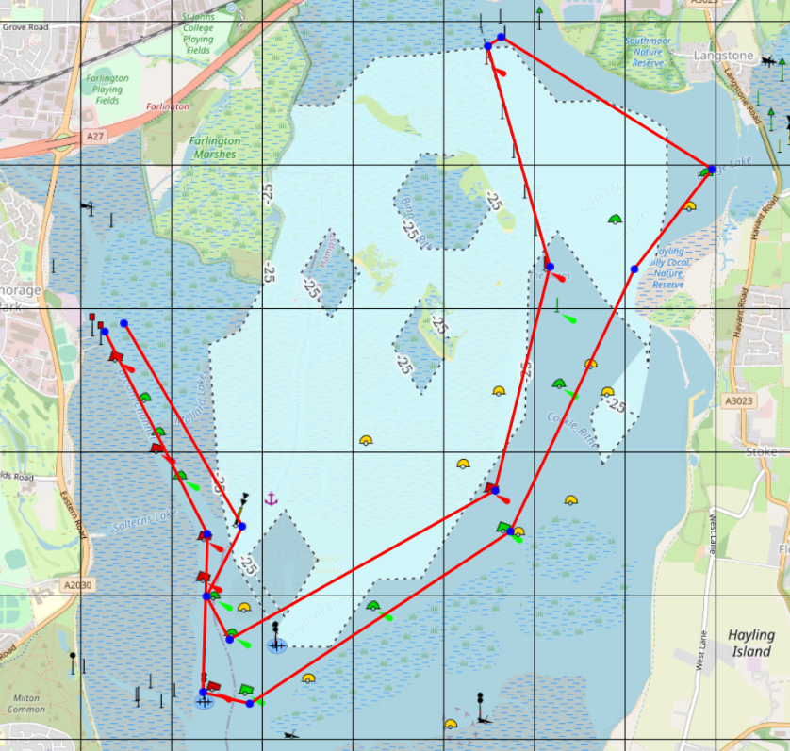
10 Mile Course Details

1
2
3
4
8
9
10
11
5
6
7
0

 | Description | Leve at | Photo
0 | Start/finish | - | -
1 | Mallard South Cardinal Buoy | STARBOARD | 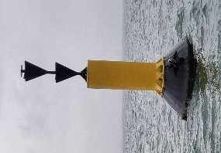
2 | West Sword Green buoy | PORT | 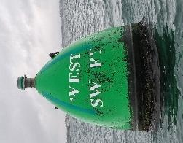
3 | Sword Point  Green Buoy | PORT | 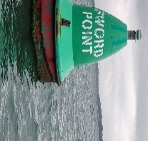
4 | Alpha  Red Buoy | PORT | 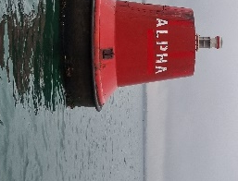
5 | Red Post | PORT | 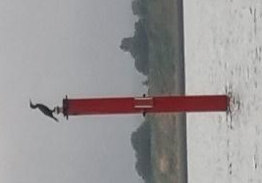
6 | Bedhampton Triangular Post (white) | STARBOARD | 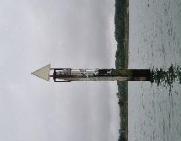
7 | Bridge  Green Buoy | STARBOARD | 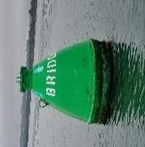
8 | Rod  Green Buoy | STARBOARD | 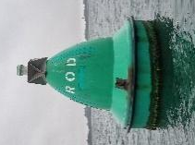
9 | N. W. Sinah Green Buoy | STARBOARD | 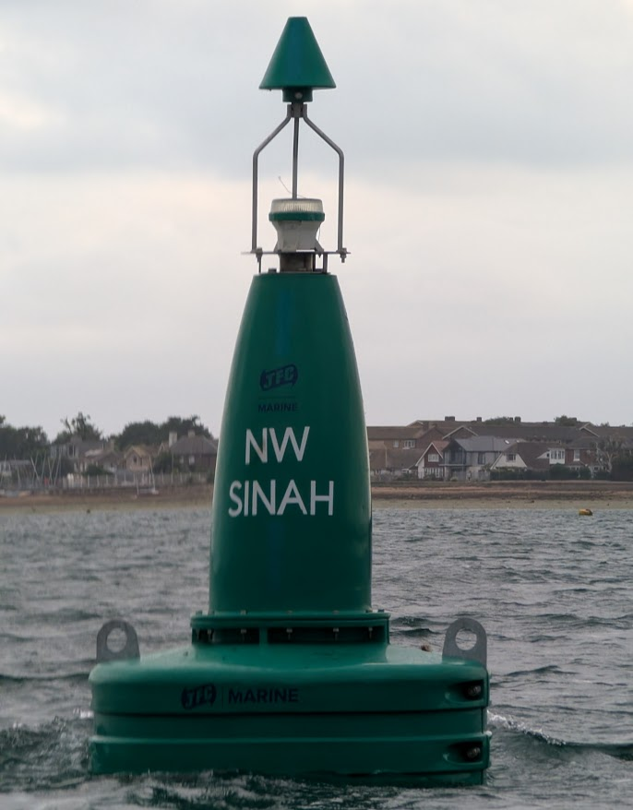
10 | East Milton Red Buoy | STARBOARD | 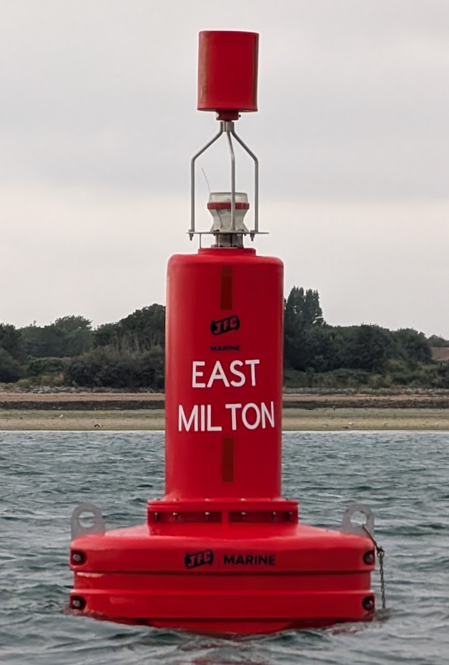
11 | Salterns  Red Buoy | PORT | 