10 Mile Course Details

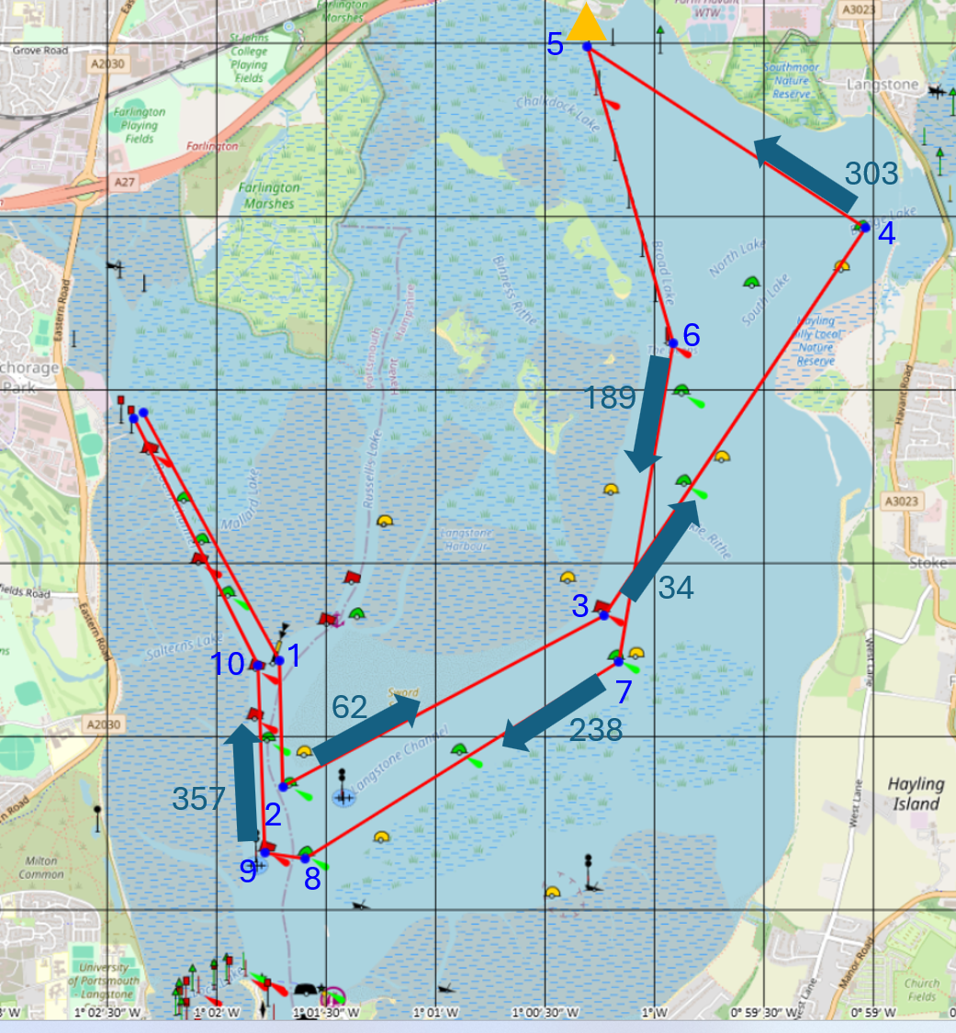

 | Description | Leave at | Photo
1 | Mallard South Cardinal Buoy | STARBOARD | 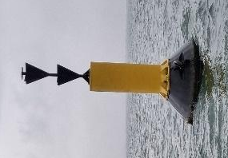
2 | Sword Point  Green Buoy | PORT | 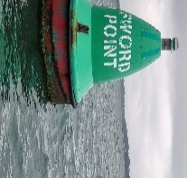
3 | Alpha  Red Buoy | PORT | 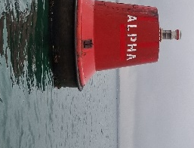
4 | Bridge  Green Buoy | PORT | 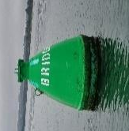
5 | Bedhampton Triangular Post (white) | PORT | 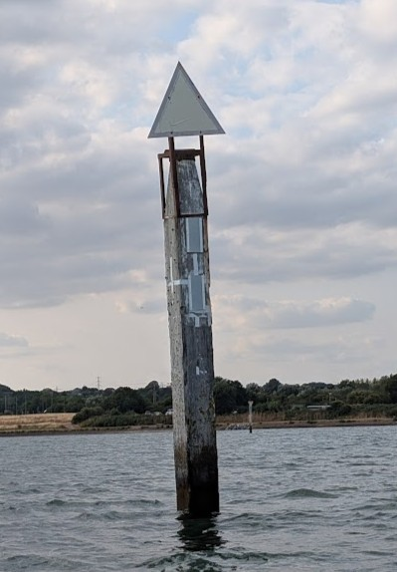
6 | Red Post | STARBOARD | 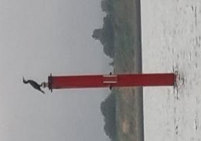
7 | Rod  Green Buoy | STARBOARD | 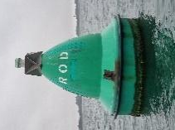
8 | N. W. Sinah Green Buoy | STARBOARD | 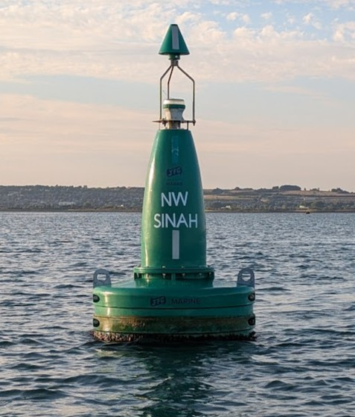
9 | East Milton Red Buoy | STARBOARD | 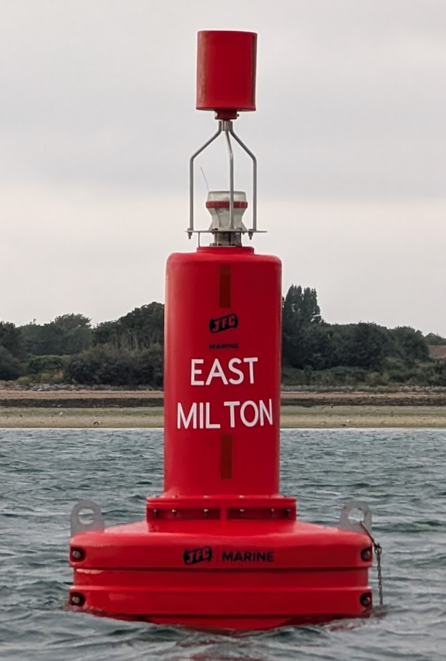
10 | Salterns  Red Buoy | PORT | 